|  |  |
| --- | --- |
| Assignment Date | 30th October 2022 |
| Student Name | VIKRAM P |
| Team ID | PNT2022TMID15316 |

**Problem:**

**PHARMA MONTHLY SALES DASHBOARD**

**Dataset:** [**Pharma Dataset/view**](https://drive.google.com/file/d/1t2PVp4xOzr94GFXRWz5WBOBv_nE4OGKu/view)

**Challenge:- Upload the dataset to Cognos Analytics, prepare the data, explore and Create Interactive Dashboard.**

**Task 1:Sales By Customer.**

**Task 2:Sales By Location.**

**Task 3:Sales By Sales Representative.**

**Task 4: Received Inventory From Supplier**

**Task 5: Inventory Stock for Warehouse Locations**

**Task 6: Sales Trend**

**Task 7:Monthly Sales**

**Task 8: Actual and Received Inventory by Month**

**1.Uploading Dataset to IBM Cognos Analytics:**

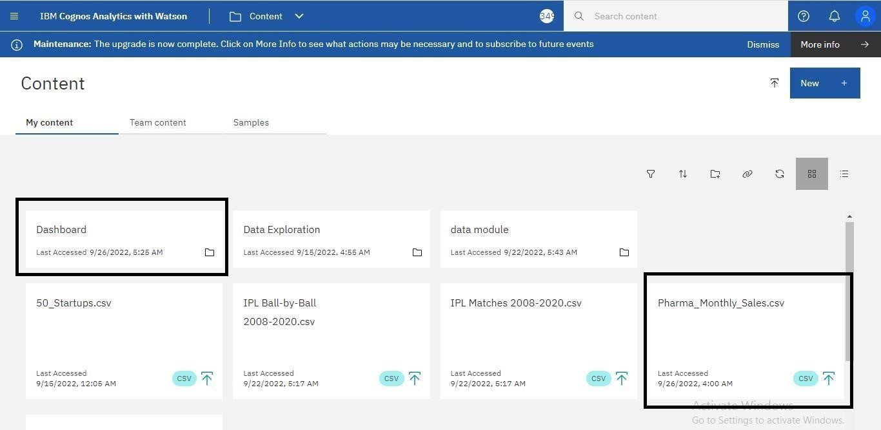

**2.Data Preparation:**

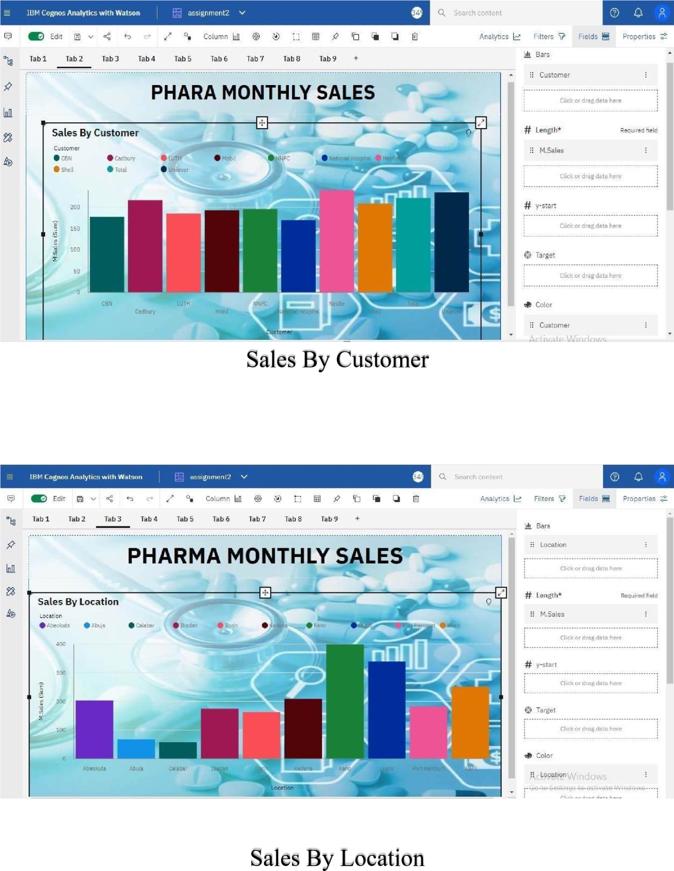



Sales By Sales Representative

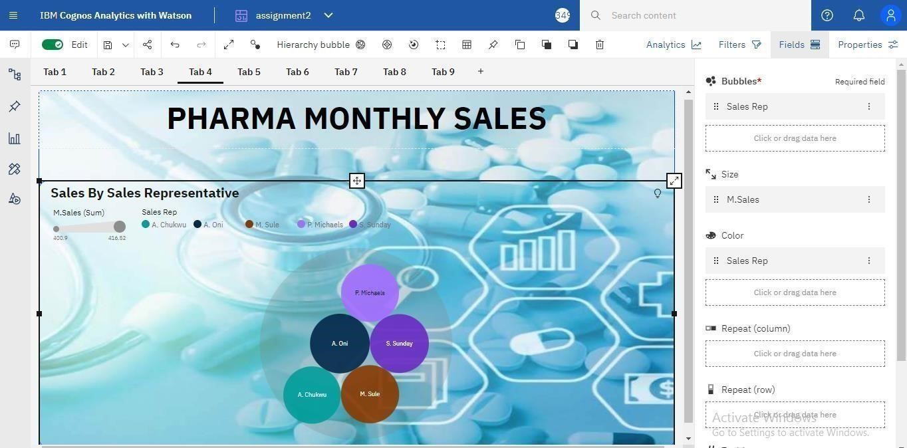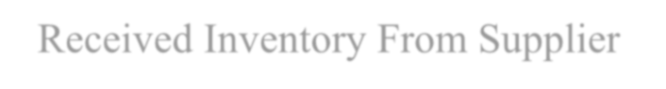

Received



Inventory From Supplier

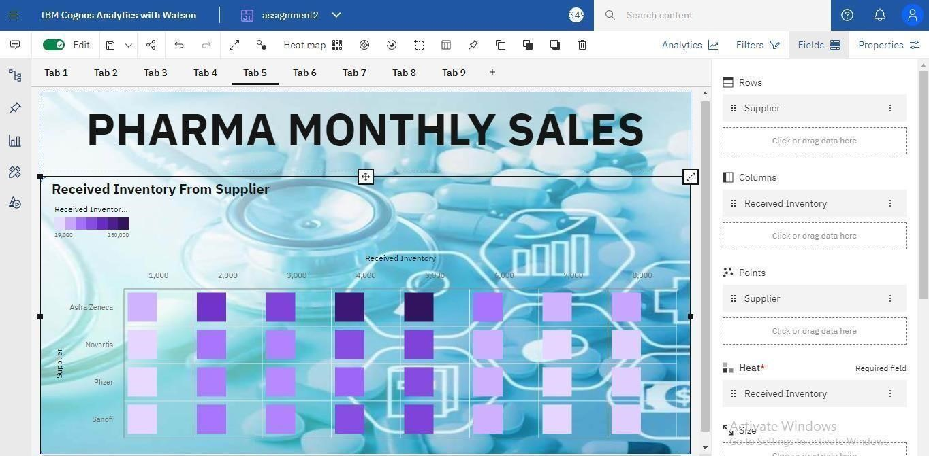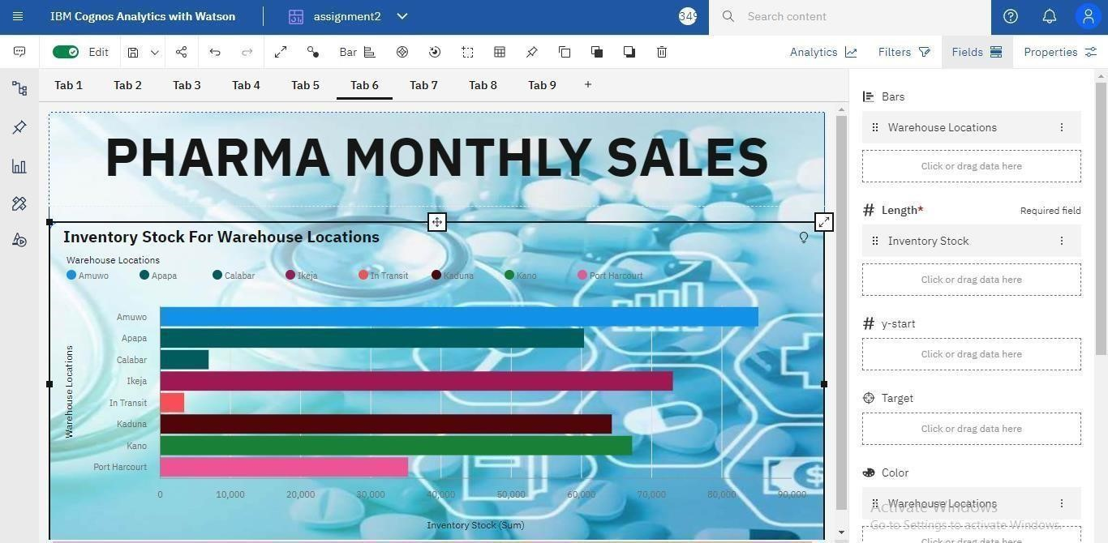

Inventory Stock For Warehouse Locations



Sales Trend

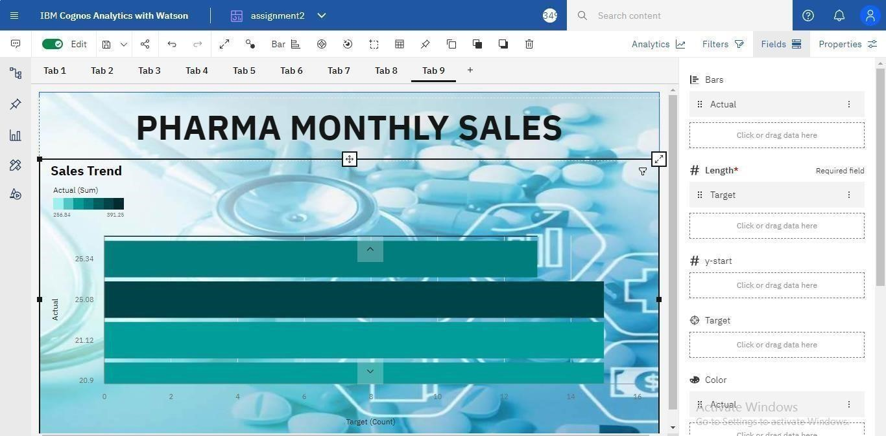

Monthly Sales

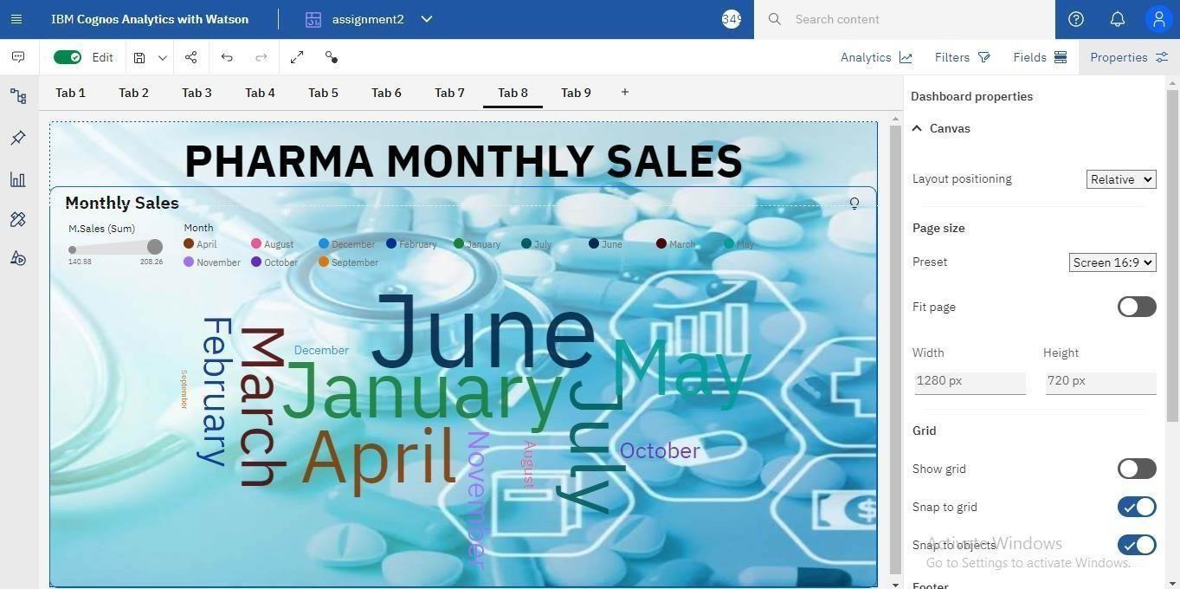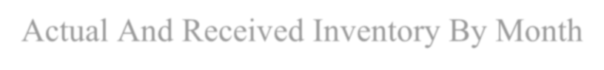

Actual And Received Inventory



By Month

